School of Computer Science Engineering & Information Science
A Report on
Mini-Project
Titled “Your project title”

Course Title: Web Technologies
Course Code: CSE2258
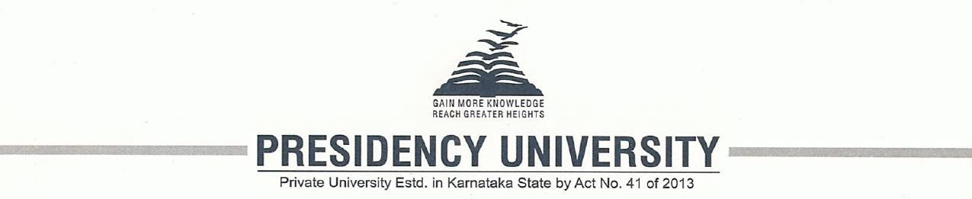
Date of Submission: 22/11/2025

Submitted By:
Sandhyana 20241IST0070
S.Yashwanth Kumar 20241IST0071
Sahil raj 20241IST0072
Premjith 20241IST0073
Mansoor 20241IST0074

Index
- Abstract
- Introduction
- Software and Hardware Requirements
- Modules/Functionalities
- Results with Screenshots
- Conclusion

Abstract:
The Digital Library Management System is designed to replace traditional manual library work with a modern, automated, and computer-based system. In many libraries, book issue, return, cataloguing, and record maintenance are still done using paper files, which often causes delays, mistakes, and difficulty in managing large amounts of data. This project aims to solve these problems by providing a digital platform where all library functions can be handled easily and accurately.
The system allows users to quickly search for books using keywords, check the current availability of books, borrow and return books online, and receive reminders before the due date. It also helps librarians maintain records more efficiently by reducing manual work and preventing errors that commonly occur in paper-based systems. By offering features such as real-time updates, smart search, online reservations, and automated notifications, the system improves the overall library experience.
This project not only saves time for students and library staff but also ensures that the library functions smoothly and systematically. The Digital Library Management System supports modern education by providing fast access to knowledge and making library services more convenient, reliable, and accessible to everyone.

Introduction:
Libraries play an important role in providing knowledge and resources to students, teachers, and researchers. However, many libraries still depend on traditional manual processes such as writing book details in registers or managing records in paper files. This method often causes problems like slow service, misplaced books, long waiting times, and difficulty in searching for information. As the number of users increases, these issues become harder to manage.
The Digital Library Management System provides a solution to these problems by digitizing the entire library process. It offers an online platform where users can easily search for books, view their details, borrow or return them, and get updates about due dates. Librarians can also manage all book records, user details, and transactions through the system without relying on paperwork. This makes the library more organized, reduces manual workload, and increases accuracy. The system supports a modern learning environment by offering faster access to information and improving the overall efficiency of the library.

Software Requirements:
- HTML – For design the structure of the web pages.
- CSS – Used to style and format the appearance of the website
- Web Browser – Google Chrome / Firefox / Edge to run and test the system.
- Code Editor – VS Code / Notepad++ / Sublime Text for writing code

Hardware Requirements:
- Laptop/Desktop
- Internet Connection – Required for browsing, testing, and accessing resources.

Modules/Functionalities of Digital Library Managements:
The Digital Library Management System is divided into several modules, and each module has a specific function to make library operations easier:
1. Registration Module:
This module allows new users to create an account by entering their basic details. After registration, they can log in and access the system.
2. Login Module:
The login module ensures that only registered users can enter the system. It checks the username and password for security purposes.
3. Home Page:
The home page acts as the main dashboard. It provides easy access to different features like viewing book lists, searching for books, and borrowing books.
4. Books List:
This module shows all the available books in the library. Each book is displayed with details such as title, author, category, and availability status.
5. Borrow Books Module:
This module allows users to borrow a book by selecting it from the list. It also shows the due date, so users know when they need to return the book.

Results With Screenshots:
The Digital Library Management System successfully displays all the main pages, including the Registration Page, Login Page, Home Page, Books List, and Borrow Books page. Each page works smoothly and provides clear navigation for users. The system allows users to easily search for books, check availability, and borrow them without confusion. All records are updated automatically, which reduces manual work for librarians. Overall, the system is functional, user-friendly, and improves the efficiency of library operations

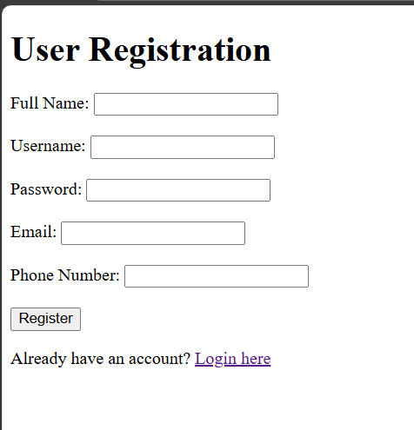
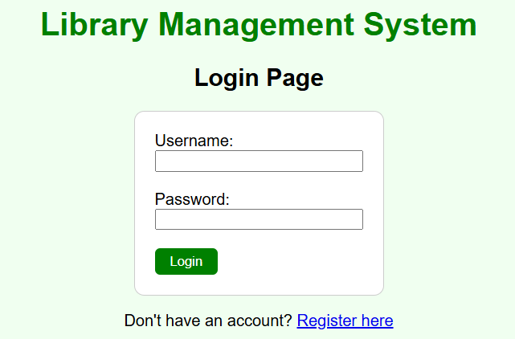

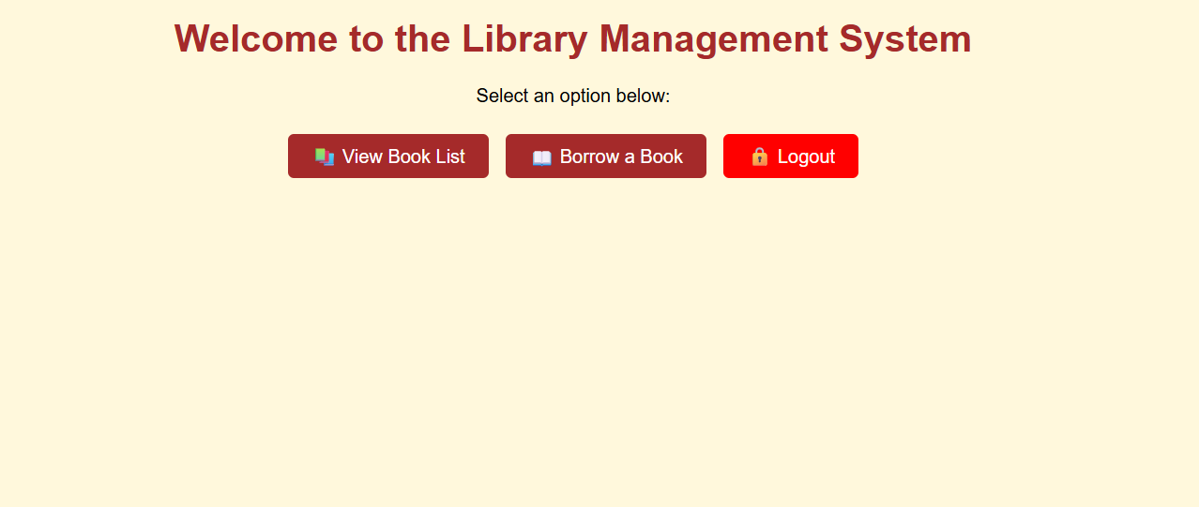

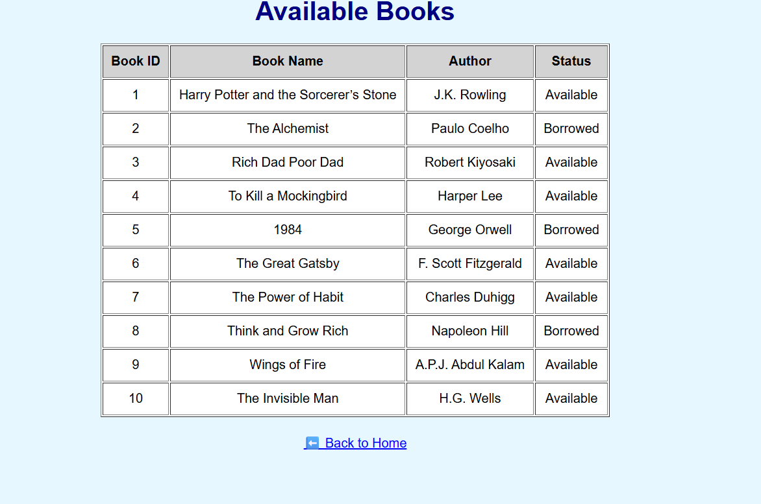

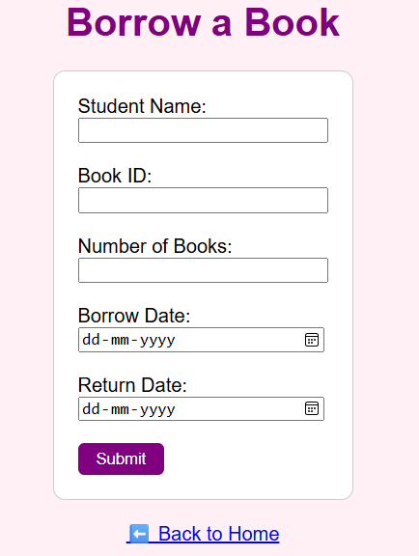

Conclusion:
The Digital Library Management System has proven to be an effective solution for improving the way library tasks are handled. By shifting from manual processes to an automated system, it reduces errors, saves time, and makes book management much easier. Users can quickly search for books, check their availability, and borrow them without confusion. The system also keeps all records updated automatically, which helps librarians manage the library more efficiently. Overall, this project creates a modern, well-organized, and user-friendly library environment that supports better learning and provides faster access to information for everyone

